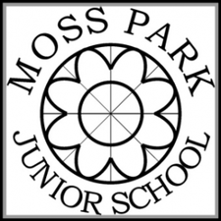
Year 4
Spring Term
Essential Word List
These words have been taken from the Y3 and Y4 National Curriculum spelling appendix. They do not necessarily follow a spelling rule and can be classed as ‘tricky’ words. Children will be tested on these words throughout the term and should practise them at every opportunity as part of their ongoing homework. We will let you know which ones your child found difficult after each test so that you can focus on those words. Thank you.

actual  actually  bicycle  breath  century  complete  describe  early  enough  famous  favourite  grammar  guard  imagine | important  knowledge  length  material  medicine  mention  natural  naughty  ordinary  particular  peculiar  possible  potatoes  strength  suppose

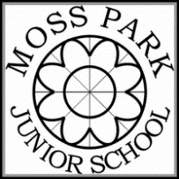
Year 4
Summer Term
Essential Word List
These words have been taken from the Y3 and Y4 National Curriculum spelling appendix. They do not necessarily follow a spelling rule and can be classed as ‘tricky’ words. Children will be tested on these words throughout the term and should practise them at every opportunity as part of their ongoing homework. We will let you know which ones your child found difficult after each test so that you can focus on those words. Thank you.
although  arrive  business  calendar  consider  continue  experience  extreme  guide  heard  increase  interest  island  library | perhaps  popular  possess  probably  promise  purpose  quarter  recent  regular  remember  separate  special  therefore  various

