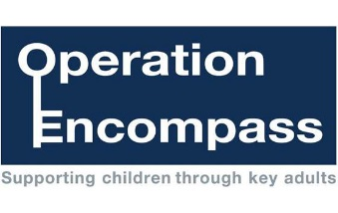

Our school is part of a project, which is run between Trafford Local Authority, schools and Greater Manchester Police. The project called Operation Encompass, has been designed to provide early reporting of any domestic abuse incidents that occur outside school, which might have an impact on a child in school. This is communicated through a secure email to school following an incident.
The project ensures that at least one member of the school staff, known as the Key Adult, is available to liaise with children's services and the police and to use the information that has been shared, in confidence.
In this way, we aim to support each child who has been involved in, or witnessed, a domestic abuse incident.
The Key Adult /s at Moss Park Junior School is Sally Nunwick, Headteacher.
If she receives an Encompass notification she will make sure that a person the child trusts is available to help - if the child needs this. Most of the time this support is silent; keeping a careful eye on him or her and making sure the child has a calm school day. The confidential information is ordinarily not shared with all staff, just an agreement on how to help, if needed.
All schools have a duty to share any information with other organisations if they feel a child is at risk of being hurt. The Key Adult may contact other organisations.
The sharing of information from the police allows the school to be ready to help your child straight away, and it means that parents are aware that the Key Adult knows that something has happened. Parents can come and talk to our Key Adult. The Key Adult can point you towards other people that can help.

Our aim is to support children and their families.

