Moss Park Junior School
Preventing and Managing Sickness including outbreaks
Risk Procedures and Risk Assessment

Progression of restrictions / Staged Response
At Colebourne we have 4 stages for when dealing with medical incidents / outbreaks. Depending on the nature of the situation and stage can be

Response Stage | Trigger | Key Actions | Who | Notes
STAGE 1 – General  (everyday hygiene and procedures) | None | - General reminders for hygiene  - Effective handwashing facilities and soap available  - Follow usual absence periods for sickness
STAGE 2 – Prevention | Where an increased risk is present  - Increased absence rates of pupils or staff  - Local increases in sickness e.g. flu, gastric, coronavirus  - Public health alerts  - Suspected cases of specific illness in school or within the community (eg.coronavirus / gastric) | - Increase hygiene procedure  - Communication with key people including key information (staff, pupils and families, users of the site)  - Specific hygiene lessons in class  - Increased enforced use of handwashing before eating of food  - Enforce 48hr after symptoms have stopped for all fever, sickness, diarrhoea etc.  - Consider the types of trips and events and make changes as necessary (e.g. those where lots of close contact / touch points)  - Review Core Control Measures and make changes as necessary  - Daily review of the situation | SLT  Admin  Staff | Have changed Parents evening 20 23/4/20
STAGE 3 – Mitigate/ Delay | Where a significant risk is present  - direct case or increased likelihood of cases  - Public health advice for restrictions | Consider reducing contact situations:  - Assemblies  - Carpet time  - School events  - Trips  Consider:  - Any screening measures e.g. use of a thermometer in school.  - Increase time of exclusion from school for those with symptoms (beyond 48hrs)  - Sending home any children with any symptoms  - Additional Cleaning including deeper cleans (handles, toilets, push panels, taps and water fountain) | SLT
STAGE 4 – Containment | Where specific and/or significant changes or restrictions need to be in place.  - High levels of sickness  - High rates of absence  - Significance of danger of disease or illness | - Part / full closures of site / classes  - Deep cleans  - Closure of lettings and building use  - Reduction or exclusion of visitors | HT / Chair of Governors

Coronavirus Key Actions (as situation escalates)
Specific Issue | Actions including messages | Who | Notes
Suspected case in school (staff or pupil) | - Contact relevant agencies e.g. LA / Public Health England  - Deep clean core areas  - Inform staff  - Core reminders of hygiene  - Contact parents – general information about sickness etc. | SLT
Confirmed case in school | - Deep clean core areas  - Inform staff  - Core reminders of hygiene  - Contact parents – general information about sickness etc. and the key next steps e.g. closure of a class / school/ or carry on etc. | SLT; Site
Suspected case in a family | - Parents to ensure child washes hands before leaving the house.  - Child to wash hands immediately after coming into school  - Increase monitoring of pupils | Families; Staff; Admin
Confirmed case in a family | - Children in the family to remain at home for a fixed period of time  - Deep clean of the classroom and school | SLT  Site manager | Have set up info@mpjs-trafford.co.uk for parents to let us know if they have been into contact with a coronavirus sufferer/are self-isolating etc. if the school is closed and regular channels are not available.
Teacher shortage | - Supply / Splitting classes / SLT Cover  - Where too many – partial closure for certain classes or part time / AM / PM classes | SLT
Support staff shortage | - Supply / Prioritise most needy children / classes with remaining staff | SLT | Have discussed pupils with Health Care Plans with 1st Aid Team
Protection for most vulnerable children | - Identify who these children are vulnerable e.g. underlying health conditions that may be affected by the current threat  - Discuss with parents the initial steps and agree key actions re. isolation/seclusion | SENDco. HT; families
Staff with health issues (e.g. Heart) | - Ask them to contact their consultants to seek advice on their condition  - Consider working from home | SLAM  Staff
Staff with symptoms | - Stay at home; follow NHS 111 advice; discuss with HT | HT
Pregnant staff | - Ask them to contact their midwife to seek advice;  - Consider working from home | SLT
Kitchen shut down | - Parents to provide packed lunches | SLT; Families | School would buy/make sandwiches for pupils if needed (with food hygiene certificate)
Site team shortage | - Discuss with cleaning contractor cover arrangements in good time | Site
Leadership shortage | - Access via phone | SLT; Staff
Admin shortage | - Cover with TAs / SLT  - Inform parents not to phone unless emergency | Site
Other school users | - Inform of control measures, including the possibility that a suspension or usage may occur. | Site | Have text group for:  Mr Jordan  Miss Jones  Trafford Music service  Educational Psychologist  LAC Tutor  Nathan Lowe
Long period shut down | - Continue learning activities through Class Dojo and Text messages  - Children to take Power Maths books home with them and will be directed to which units to do  - Possible use of technology to deliver assemblies / stories etc. | SLT; Staff | Have plan in place – initial pack of work is ready to go and work will be set via School Website (Class Blogs).  Should the closure be longer than a week, Google Classroom will be used, giving teachers the chance to mark work and give feedback. Extra paperwork given to the children we know do not have internet in the home.  Teachers2parents – all staff have log in.

Core Control Measures
Control Measure | Control Stage | Notes / Action | Who | Review
Tissues for Each Class | 1 | - Ensure adequate stock levels of tissues for each class / office  - Replenish as needed  - Staff to also self-replenish from stock | Site; Staff
Alcohol based gel | 1 | - Additional dispenser fitted in main atrium  - Ensure dispensers and full from the start of each day  - All children to use this (or have washed hands) before lunch daily  - Ensure adequate stock levels | Site; Staff; Lunch Staff | We have extra order in with System Hygiene
Increase hand washing facilities | 1 | - We have doubled soap dispensers in the sink areas – 4 sinks available to each shared area in addition to lavatories and gel dispensers | Site
Other users of the building | 2, 3 | Contact every user and inform them of usage expectations:  - Clean hands or use gel before using facilities  - Restrictions or suspensions of usage | Site; office staff | Website, installed signs, videos
monitoring daily any child or staff absence | 2 | - Daily report to the HT or number of absences and symptoms  Weekly summary data for each class to HT | Admin; HT
finding out about travel arrangements now and in the future of staff and pupils | 3 (where specific threats are evident aboard) | Newsletter:  - Ask parents to inform us of any closes family member who has returned from abroad within the last month  - Staff members to inform SLT of any travel arrangements to high-risk areas including those of any close friends or family they have been in contact with. | Admin; HT
Reducing contact point activities | 2 | Ensuring extremely high hygiene for any  - Food making / tasting  Avoid any activity where you are passing items around a class  - Circle time objects  - Artefact sharing  - Touching activities – PE / Gymnastics  Other  - Cease hand shaking of children and visitors  - Cease and use of shared cups in class (e.g. using cups for water); replace with disposable cups; inform parents to ensure children have water bottles in school. | Staff | SM to check swimming lesson protocols
Good Personal Hygiene | 2 | Newsletter:  - Inform parents of hygiene expectations and to discuss with children;  - All children to wash their hands before coming to school, before going home and when they get home.  - Classes to teach children hand washing techniques  - Children to wash hands before snack (classroom) and before eating dinner (classrooms/ hall corridor toilets / hand sanitiser)  Information:  - Distribute key information posters | HT; Staff
Review of cleaning | 2, 3 | - Meet with cleaning contractors to review cleaning arrangement and make any necessary changes  - Increase focus cleaning on touch points and tables (redirect from vacuuming etc. if needed) or increase hours (cost?)  - Daily cleaning of classrooms (already in place)  - Preparations for deep cleans if necessary | Site; Cleaning Contractor
Additional touch point cleaning daily | 2, 3 | - Handles and rails to be cleaned at mid points during the day | Site | Done 10.30 am each day;  Corridor doors open
School visitors and site users | 2, 3 | - Compulsory handwashing / use of gel before entering school;  - Inform them of new requirements and risk of suspension of use  - Informing us of any suspected or confirmed cases by any users | Office;  Site
Absence policy | 2 , 3 | - Review time period of absence for ill children or staff and increase if necessary but at least to the minimum standard (e.g. 48 hrs clear of sickness / diarrhoea | SLT
Support for families affected | 2, 3 | - Communicate to parents and staff to contact school if they require support;  - Regular contact with affected families and staff – wellbeing checks. | SLT; Kitchens
Taking temperature of anyone in school who may begin to feel unwell | 2, 3 | - Purchase hand held non-contact thermometer. | SLT

Moss Park Junior School - Preventing and Managing Sickness
Information for staff, visitors
and building users
STAGE 2 - PREVENTION

We currently increased precautions in place to ensure effective the prevention of the spread of illness.
All users of the building are asked to follow the following guidance:

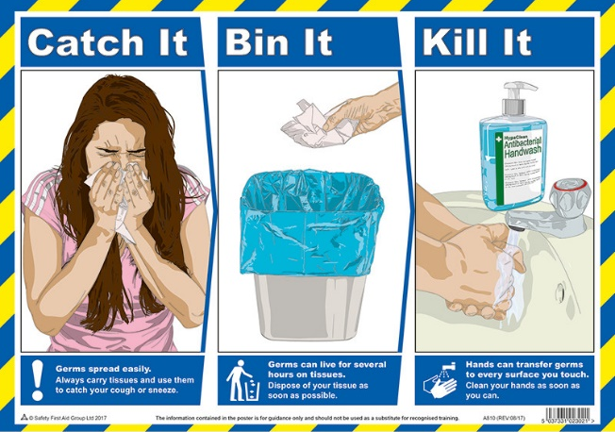
Do
- wash your hands with soap and water often – do this for at least 20 seconds
- always wash your hands when you get home or into work
- use hand sanitiser gel if soap and water are not available
- cover your mouth and nose with a tissue or your sleeve (not your hands) when you cough or sneeze
- put used tissues in the bin straight away and wash your hands afterwards
- try to avoid close contact with people who are unwell

Don't
- do not touch your eyes, nose or mouth if your hands are not clean
If you think you might have coronavirus, have been to a country or area with a high risk of coronavirus in the last 14 days or you've been in close contact with someone with coronavirus ring NHS 111. Visit https://www.nhs.uk/conditions/coronavirus-covid-19/ for further details.

Moss Park Junior School - Preventing and Managing Sickness
Information for staff, visitors
and building users
STAGE 3 - MITIGATE/ DELAY

We currently increased precautions in place to ensure effective the prevention of the spread of illness.
All users of the building are asked to follow the following guidance:

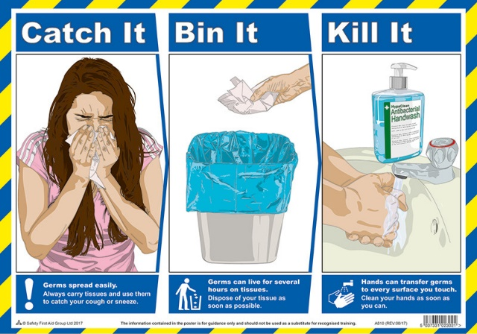
Do
- wash your hands with soap and water often – do this for at least 20 seconds
- always wash your hands when you get home or into work
- use hand sanitiser gel if soap and water are not available
- cover your mouth and nose with a tissue or your sleeve (not your hands) when you cough or sneeze
- put used tissues in the bin straight away and wash your hands afterwards
- try to avoid close contact with people who are unwell

Don't
- do not touch your eyes, nose or mouth if your hands are not clean
- enter the school if you are feeling unwell or have been in close contact with any person who is unwell (staff should contact the head teacher to discuss).

If you think you might have coronavirus, have been to a country or area with a high risk of coronavirus in the last 14 days or you've been in close contact with someone with coronavirus ring NHS 111. Visit https://www.nhs.uk/conditions/coronavirus-covid-19/ for further details.
Moss Park Junior School - Preventing and Managing Sickness
Continuation of learning Plan if school closure for a prolonged period

- Staff to communicate to pupils via school website www.mpjs-trafford.gov.uk on class blogs every day to keep communication going with pupils
- Children to have the equivalent of 1 maths and 1 English activity per day (based on current topics if possible)
- Staff to set an additional project / longer task where appropriate
- Other core learning to complete:
  - Any online learning available e.g. TT Rockstars, My Maths, Bitesize BBC
  - Any outstanding activities on their homework grids
  - Daily Reading
  - Exercise books for activities designed by teachers
- Children to submit work, where appropriate, via Google Classroom (in second week and beyond)
- School based message to parents explaining the above and the expectations from parents to support this

Moss Park Junior School - Preventing and Managing Sickness
Information for lettings users
STAGE 2 - PREVENTION

Dear School User,

In order to ensure we do what we can to reduce the risk of illness in school we have a clear strategy plan in place.
Part of this strategy includes, where there is an increased risk of illness, implementing additional cleaning, hygiene expectations and certain restrictions.
At the moment we have increased our level of response to stage 2 – PREVENTION. This is to ensure we do what we can to prevent/ reduce the chance of illness developing or the further spread of illness.
At this stage, you are able to continue to use the school facilities, but we ask that you ensure that all those using the building as part of your company comply with the following:
• Wash your hands as you enter the building or use the hand sanitisers
• Wash your hands frequently
• Avoid unnecessary contact (no shaking hands)
• Avoid touching your face including mouth, nose and eyes
• Sneeze into your elbow or a tissue (not your hands)
• Put any used tissues in the bin and then wash your hands

We have included a poster which you may wish to circulate to your users.
We also ask you to inform us if any of your users are confirmed to have the coronavirus; this will help us to develop our response and ensure deep cleaning takes place.

If we need to take further precautions and move to stage 3 - MITIGATE/ DELAY, we will be in touch again; at this stage we need you to know that we may need to reduce or cease your ability to use the facilities for a period of time.

If you have any questions, please get in touch with me: snunwick@mpjs-trafford.co.uk or John Irvine (Site Manager) jirvine@mpjs-trafford.co.uk

Mrs S Nunwick
(Head Teacher) PHONE: 0161 864 1710 (07963937371)

