Team Hawking
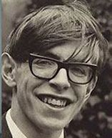
Maryam
Lola-Gray
Hiba
Hijaab
Ruby
Uhbaan
Oscar
Hassan

