Team Pankhurst
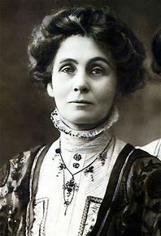
Bushra
Jack
Zach
Arabella
Jaya
Zara
Adam
Lucas

