Team Parks
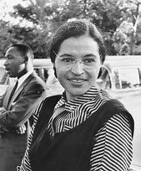
Shuja
Reuben
Mishal
Yakoub
Yasmin
Lyla
Thomas
Jessica

