18/1/21
Trumpets on Home Delivery?
Music Lessons Proving to be
Essential in Lockdown

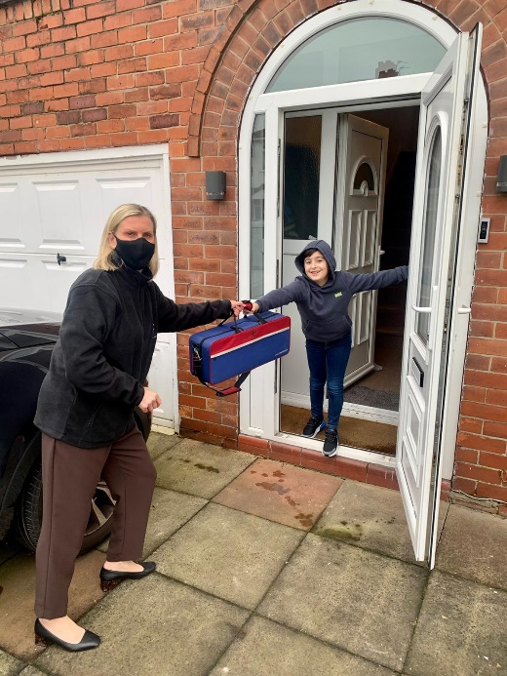 | 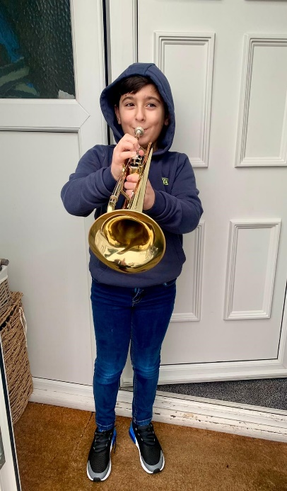

[caption: Lorenzo Pieri, Year 4 Student at Moss Park Junior School receiving his home delivered trumpet from head teacher Sally Nunwick].
Trafford teachers are going over and above to make sure that students receive their music lessons during Lockdown. Indeed, teachers and parents are recognising the importance of music lessons that school teachers themselves are taking it upon themselves to deliver instruments to students’ homes. Trafford Music Service, the council’s music education service, has experienced a constant demand for music lessons by schools and by parents throughout the pandemic.
Head Teacher, Sally Nunwick from Moss Park Junior School in Stretford, and her team have been out delivering trumpets to their students in Year 4, direct to their homes. The teachers are making sure that the pupils could take part in the whole-class tuition on Monday mornings, with specialist trumpet teacher from Trafford Music Service, Becky Jones.
Sally commented:
“We didn’t want any child to miss out on having their trumpet lessons so that’s why we delivered the instruments to the homes where the parents couldn’t collect them from school. It’s important that our students continue with their education and that we enable all our pupil’s to achieve their potential, despite the challenging circumstances.”

