Year 5 Curriculum Fact Sheet for Pupils and Parents – Autumn 1 (20-21)
English  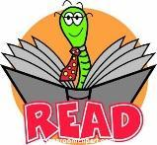 | Fractured fairy tales  - Fairy tales  - Openings and endings  - Non-chronological report  - Modal verbs, relative pronouns, clauses, adverbials of time, adverbs
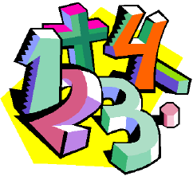  Maths | - Place value  - Addition and subtraction  - Word problems  - Statistics  - Multiplication and division  - Perimeter and Area
Science | Earth, space and beyond  - Look at our Solar System  - Name the planets in order from the sun  - Describe the movements of the moon, Earth and sun  - Explain how planets in our Solar System are organised
Other Subjects | Geography - How is our country changing?  - Learn about how the wars changed our country  - Discover how our local area has changed  - Predict what changes will occur in our local area in the future  - Learn about the 2012 Olympics and how they changed London  Computing – Every child wants to be a “YouTuber”  - Look at what a YouTuber is  - Discuss the positives and negatives of being online  - Learn how to stay safe when creating videos online  - Learn how to create their own video blog (vlog)  RE - Believing - Why do some people believe God exists?  - Learn from religious and non-religious groups about belief in God  - Investigate what different people believe about God  - Question whether we need to prove God’s existence  PSHE - Emotional Wellbeing - What makes up our identity?  - Recognise that there are differences and similarities between people  - Investigate how individuality and personal qualities make up someone’s identity  - Discuss stereotypes and how to challenge assumptions made by others  Spanish - Other Spanish speaking countries - South America  - Expressing feelings, possessive adjectives, questions and answers to build conversations, nouns (people), conjunctions
Home learning and helpful information | - Homework is set every Friday and should be completed by Wednesday morning.  - Practising reading, spellings and times tables everyday has the most impact on learning!  - Please bring your reading book and record every day. Anything you read outside of school (comics, newspapers, magazines) can be written inside.  - Year 5’s PE day is on a Wednesday. You should wear your PE kit to school on this day (don’t forget to put trainers/pumps in your bag for other days).  Miss Horvath and Miss Axon

